Lab Task Week 12

Objective:
- Conditional Filter
- Sorting
- Group
- Data Visualization

Note: You need to download the files from BBLearn.
- Lab_Task_12.ipynb and
- Marks.xlsx

Lab Task - 10

- Open your google chrome browser
- Go to the website https://colab.research.google.com/
- Press the Sign in Button on top right and sign in to your google account.
- Select upload notebook from the File menu and drag/drop the Lab_Task_12.ipynb file from your computer.
- Click on the files option from the tool menu to add the data file.
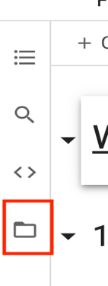

Note: Wait till the runtime is connected to see the options of file.

- Click on the upload option and choose the marks.xlsx to upload it with the project.
Note: Uploaded files will get deleted when this runtime is recycled. You need to reupload it if runtime is recycled.

- To upload the data file | - After data file is added
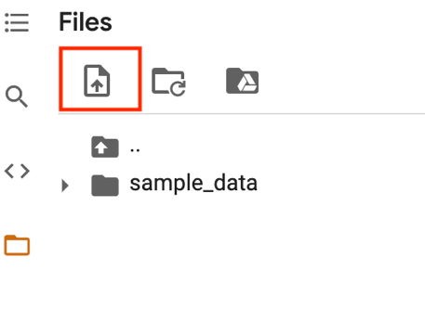 | 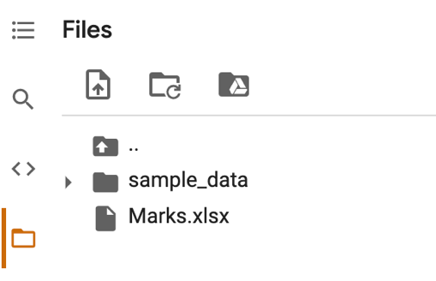

- From the Runtime select Run All to run all the commands from Week 09 and Week 10 labs.

- Complete the below Lab Tasks and type the code in given space.

a. | Display the student who got more than 69 in Final Marks
b. | Display the student who got Final Marks between 80 to 89
c. | Display the student who study in ENG division and got FWA less than 71
d. | Display the student sort by Division
e. | Display the student sort by Division in ascending and Final Marks by descending
f. | Display the number of students in each division

Data Visualization

a. | Display a line chart to display FWA details, give title as FWA details, change the line colour to red
b. | Display a Bar chart to display students by division, give title as Students by Division
I | Display a above information using a Pie Chart.

- Download the notebook to your local computer.

